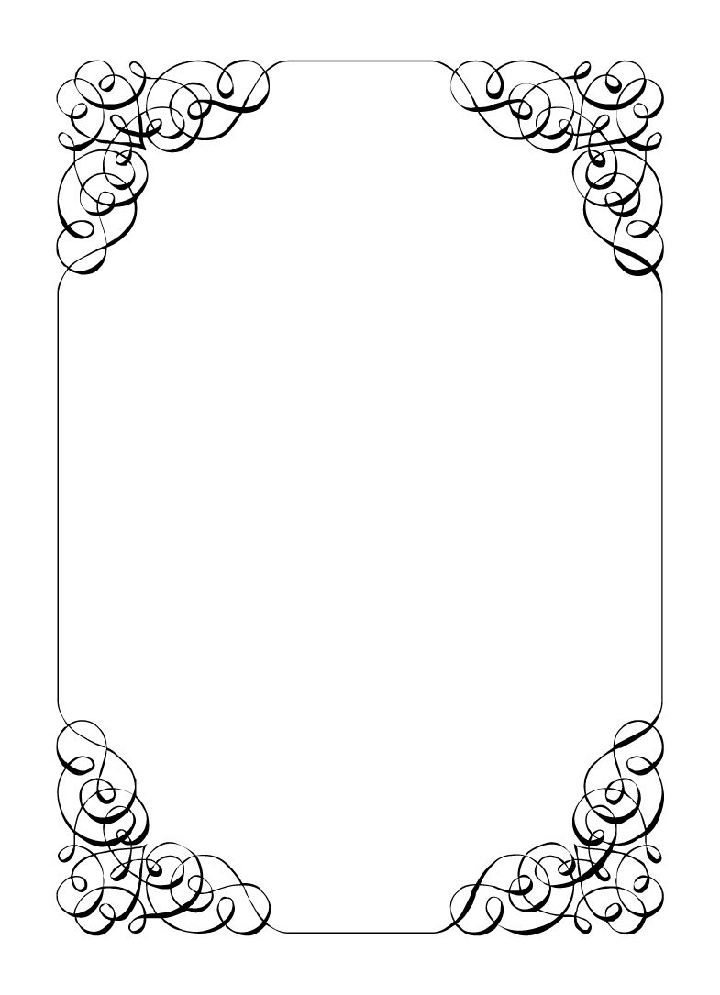

Not here to wed spiders

Sparkie Castro

*In the small town of Duck Rise, Victoria, Stralya live: BOGANS. Bogans are much like the regular folk, but drunker and louder. Some of them even fall in love. But before they settle down and poop out a mess of kids, they gotta have a wedding! Weddings are the best. Everyone gets proper plastered. Lots of kissing. Lots of drama. Fun times for all. Nothing ever goes wrong at a wedding...*  
*\*\*ominous thunder clack\*\**

Sparkie Castro

Bride's Father *Drug Addict, Emotional, Broken*

You just love Drugs! Uppers, Downers, and everything in between. The non-stop party has messed with your brain a bit, but fortunately you know a good, sensible, fix.  
Ketamine. That is the exact thing you need right now to even you out. Just gotta score some K and everything will be great.  
You also seem to be a wedding of some kind? What's that about? Oh, no... your little Corolla. 😢😢😢😢😢. Keep it together Sparkie.  
  
Last Night: You were at the Bachelor party. Dave, Wayne, Malibu, Chad, and Lucky were there. You kidnapped the Groom and brought him on a pretty nice pub crawl. You managed to get quite turped up. Plus you found your dealer and scored some Ketamine.  
Rest of the night is pretty blurry but at one point everyone put you in a taxi to go home. You have woken up with a hangover, and are ready for a bonza wedding.

**Goals**

* **Get through the ceremony without crying:** You better have some drugs on hand to make it through the ceremony. You need to hold it together for your little girl.
* **Get a date with Vectra:** It was a long time ago, but she is still as smoking as ever. If you could find a way to impress her maybe there is still something there.
* **Keep Lucky out of mischief:** Make sure if the dog takes anything you return it to its rightful owner. And keeps its nose out of the trash!
* **Find the real father:** You suspected Corolla is pregnant for a while now. But she has only been with Chad for so long. Keep it a secret but find out who the father is.
* **Daddy hugs:** Hug everyone at the wedding. Tell them how much you love them and why. They must hug back.

**Other People**

**Chad Marolla**

Well at least you know Corolla has no Father issues, Chad is about as dis-similiar to you as you could imagine. Who could be so relaxed at their own wedding?

**Corolla Castro**

Corolla is getting married. Today! It only felt like days ago that she was your little girl who needed sheltering from the world. What happened to those days. She still deosn't know she was also adopted when she was 3. You could never tell her.

**Gemini Belmont**

Gemini went to police academy and left Corolla all alone. She thinks she is so fancy with her degree and training. Pfft! Stupid cops!

**Mercedes Bennie**

You foster daughter. Her parents were killed when she was 8. You took her in, but she is a HANDFUL. Good thing she also supplies you with a coping mechanism. Clever girl.

**Robin Smith**

A little preachy, but at least they think your bloodshot eyes are from lack of sleep.

**Malibu Singer**

Malibu would often visit Corolla after Gemini left for police training. She needs friends. You would often stay up late chatting to Malibu and you know you can trust them.

**Vectra Marolla**

When Corolla introduced you to Chad you wouldn't have guessed she was Vectra's son. She still looks amazing! Just like she did during high school when you had dated for a week. I wonder if she would like to ignite old flames?

**Wayne Marolla**

An old friend from school. He was always in his own world, making up crazy ideas. Now he is just crazy. It might have been the booze. Terrible stuff. Last time you spoke was at your mother's funeral and you punched him cold out. Maybe it's time to make up.

**Lucky the Wonder Dog**

A dog from a TV show you liked called "WoWza". You liked Lucky so much, you stole them from the set. Lucky clearly likes the new life more though, so it was the right thing to do.

**Abilities**

Use these to do things. They have a limited use, so check them off when you use them.

|  |  |
| --- | --- |
| Ability | Of course, we are family |
| Promise someone a favour. If you manage this, the player must show you their other people section for the character of your choice. |
| Usages: O O O O |

|  |  |
| --- | --- |
| Ability | Want a drink? |
| Have a drink with someone (Real glass of something not an item). If you manage this, they must play rock-paper-scissors with you. If you win the player becomes intoxicated and cannot use abilities for a brief period. If you lose; you become intoxicated. (Ask an Organiser) |
| Usages: O O O |

|  |  |
| --- | --- |
| Ability | What's that I feel in you pockets? |
| Cry and hug someone (with their permission). If you manage this, the player must show you all items they have on them. |
| Usages: O O O |

|  |  |
| --- | --- |
| Ability | Chew on some Asperin |
| Show an intoxicated player this power. THey sober up and are no longer intoxicated.' |
| Usages: O O |

**Secret and Information**

Your Secret contains your guilty secret, while your Information contains one or more items of information you know. Both may be affected by abilities. Your lie may need to be filled out later.

While you can show your Secret and Information to whomever you like, you will probably not want to reveal your Secret too often. (Please note that you can’t solve the crime by looking at everyone’s Secret and Information – it’s not that easy!)

|  |  |
| --- | --- |
| Secret | You have a serious drug problem. |

|  |  |
| --- | --- |
| Information | Wayne tried to get a prenup signed but Chad blocked it. |

**The Organiser’s Word is Law:** The organisers are impartial. If you have a problem or want to do something unusual, see an organiser. The organiser’s power is absolute – and cannot be affected by ability cards!

**Winning and Losing:** You can achieve most of your goals simply by talking to people. The organisers will announce when the game is over. If you haven’t succeeded by that point – you’re too late! Be warned – not everyone here will want you to succeed!

**Doing Stuff:** Ordinary actions are resolved by simply carrying them out. If you want to try something unusual (such as trying to hack the pentagon), see an organiser. The organisers knows everything – and will be able to tell you the outcome of whatever it is that you are trying to do. (For example, you are trying to hack over state lines and you are caught.) Do use your imagination, though! – this is a very flexible game, and you can do all sorts of things beyond what’s listed in these rules.

**Fighting:** If an ability or item lets you hard another player, don’t just dive in! See the organisers first and tell them what you plan to do so they can oversee and give you more detailed rules if it’s necessary.

**Leaving:** You cannot leave, it is rude to leave a wedding and you are in the middle of nowhere!

**Role Cards:** If someone asks you for your role in the wedding ceremony, and you have one, you must show them all your roles.

**Item Cards:** Any items of importance within the game are represented as Item cards – and the only items that can affect the game are those detailed on the cards. If you do not have an Item card, you do not have that item with you.

**Time:** This game is played over three (ish) hours, including time for reading your character etc. There will be breaks throughout the evening! The organisers will tell you when each period starts and finishes.

**Character List**

**Chad Marolla – *Groom***

The soon to be husband. A bit nervous about the wedding, but is letting Corolla take care of the hard stuff.

**Corolla Castro – *Bride***

She knows what kind of wedding she wants, and that's the kind of wedding we are having! NO EXCEPTIONS!

**Gemini Belmont – *Maid of Honour***

She carries herself like she just escaped a warzone. Maybe she did? She's real quiet and might throat punch you if you ask stupid questions.

**Mercedes Bennie – *Flowergirl***

She's 12 but everyone knows better than to treat her like a 12 year old. Punk AF and will burn this all down on a whim.

**Robin Smith – *Priest***

Not from here. Better than everyone else (or at least thinks so).

**Dave Torana – *Best Man***

Childhood friends with the Groom. He was the smooth talking hottie that picked up enough for both of them. But that part of his life is over now.

**Malibu Singer – *Wedding Planner***

For a professional organiser, not very organised. Has just managed to keep everything running so far.

**Sparkie Castro – *Bride's Father***

He's been waiting his whole life for this moment. His baby girl is finally gonna get married and he knows just how to get through the day without crying...

**Vectra Marolla – *Groom's Mother***

The Queen that runs this town. Knows where the bodies are buried, but will never tell. Everyone respects her.

**Wayne Marolla – *Drunk Uncle***

He's maybe had a few too many. Started stumbling around and saying weird things. Every wedding has one.

**Lucky the Wonder Dog – *Dog***

A good dog. *bark* *bark* "What's that Lucky? You want pats?"

**Mungo Joint – *Photographer***

Seems like they are creeping on everyone, but they were hired to take wedding photos so it's probably fine.